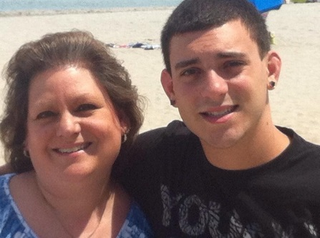 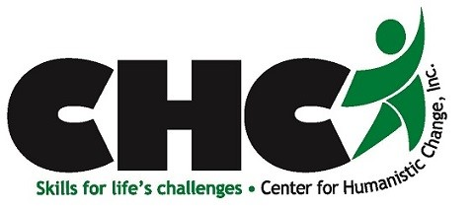

**We are in the midst of the worst drug epidemic in US history.**

Addiction is now recognized as a chronic, relapsing brain disease. Knowing this, why do people start doing drugs? How does experimentation become habit, and from there, full-blown addiction? Why is addiction considered a family disease? If a loved one has a Substance Use Disorder, what can I do? Is there any hope for someone addicted to “hard” drugs, such as heroin?

Over the past 18 months, we interviewed nearly 25 people from the Lehigh Valley, including people in recovery; parents who have lost children to overdoses; family and friends who have lived through – or are now living with – loving someone with an addiction; law enforcement officials; and healthcare workers who are on the front lines, fighting this disease as EMTs, doctors, nurses and recovery specialists. As they share their stories, you will learn about the cycle of addiction, consequences of chronic drug use, and how to find help.

**“Addiction is a family disease.**

**You can’t do it alone.”**

**-Linda J., mother of Joseph**

Liberty High School

Wednesday April 11, 2018 6:00 – 7:30 PM

## The Center for Humanistic Change engages community members in building skills to address life’s challenges.

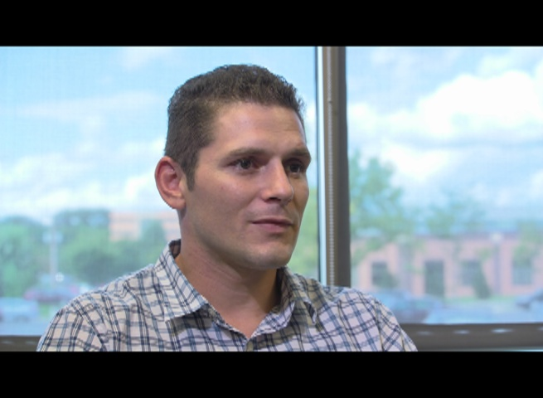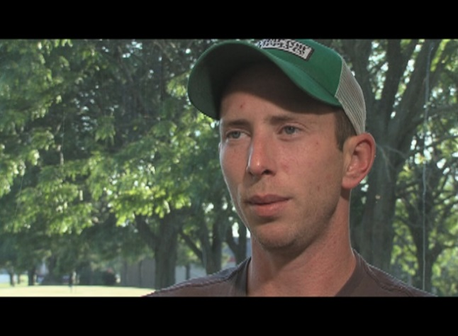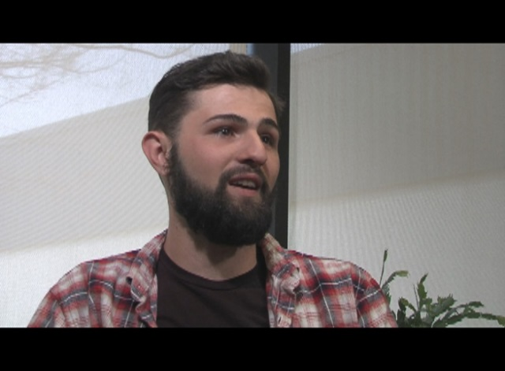

Voices from the Valley:

Addiction & Recovery

**100A Cascade Drive**

**Allentown, PA 18109**

**Phone: 610-443-1595**

**Fax: 610-443-1598**

**www.theCHC.org**

***This learning experience, the first of its kind in the Lehigh Valley, is made possible by:***