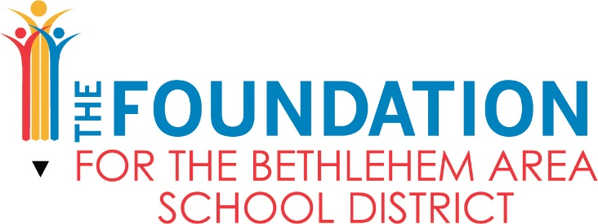

Karen Jeffress Memorial Scholarship Application

ABOUT THE SCHOLARSHIP:
In partnership with the Jeffress family, The Foundation created a fund to memorialize the accomplishments of community member and Bethlehem Area School District retired teacher, Karen Jeffress while giving back to the community. The Karen Jeffress Memorial Scholarship Fund will offer one scholarship in the amount of $1,000 each school year to a graduating Bethlehem Area School District senior who attended Marvine Elementary School. To be eligible to apply and to be considered for this scholarship, you must meet all of the criteria below.

APPLICANT ELIGIBILITY:
- Applicant must be a graduating senior at Freedom High School or Liberty High School
- Applicant must have attended Marvine Elementary School for a minimum of two full school years
- Applicant must have a minimum of a 3.0 GPA throughout their high school career
- Applicant must be attending an accredited college, university, vocational, or technical school in the Fall of their graduating year

APPLICATION REQUIREMENTS:
- Completed application form
- Copy of applicant’s transcript
- An essay in which the applicant outlines how they have achieved academic excellence, how they impacted the BASD community, and describe how you display the qualities of leadership, determination, tenacity, work ethic, loyalty, and dedication which Karen Jeffress valued.

APPLICATION PROCEDURE:
- Completed application forms, copy of applicant’s transcripts and essay must be submitted by Thursday, April 1, 2021 to Eric Fontanez, Principal, Marvine Elementary School via mail, delivery, or email:
Eric Fontanez, Principal
Marvine Elementary School
1425 Livingston Street
Bethlehem, PA 18017
Email: efontanez@basdschools.org
- The applications will be reviewed by the Karen Jeffress Memorial Scholarship committee
- The scholarship will be awarded by June 1, 2021
- A member of the Karen Jeffress Memorial Scholarship committee will notify the scholarship recipient
- The $1,000 scholarship check will be made payable to the education institution directly, not the scholarship recipient. The scholarship check will be issued from The Foundation for the Bethlehem Area School District.
- The Karen Jeffress Scholarship committee has the authority to request proof of acceptance

Karen Jeffress Memorial Scholarship
2021 Application Form
Application Deadline: Thursday, April 1, 2021

Student Name:_______________________________________________________________________

Home Mailing Address:________________________________________________________________

Years Attended Marvine Elementary School:______________________________________________

College or University chosen:___________________________________________________________

Enrollment Start Date:________________________________________________________________

Planned Graduation Date:_____________________________________________________________

Student ID or Bursar Number:__________________________________________________________

Planned course of study (please elaborate on educational plans):
_____________________________________________________________________________________
_____________________________________________________________________________________
_____________________________________________________________________________________
_____________________________________________________________________________________
_____________________________________________________________________________________
BASD High School: ________________________________ Graduation Date: _________________
Current GPA: ____________________________________ Class Rank: ______________________

Signature:________________________________________ Date: ___________________________
I understand that my eligibility for this award is based on all information provided above being accurate and reflective of my educational plans at this time.

