Lincoln Elementary School
1260 Gresham Street
Bethlehem, Pennsylvania 18017
Telephone (610) 866-8727 Fax (610) 807-5545
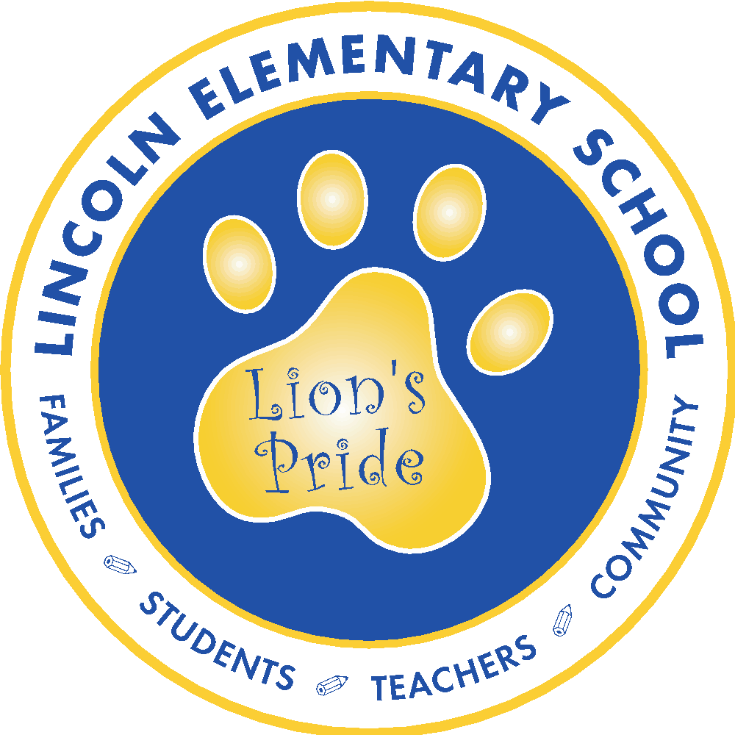

2021 Lincoln Elementary School Scholarship

Lincoln is excited and eager to award a student, either a Liberty or Freedom High School, $500.00 at graduation. We are proud to continue this annual tradition that has been established since 2005.

The criteria for being a candidate for this scholarship is as follows:
- The student must have attended Lincoln Elementary School from grades 1 – 5,
- The students may be from either Liberty or Freedom High School,
- The student must apply for the scholarship by completing and submitting the application form and writing and essay entitled, “The Value of My Education at Lincoln Elementary School by April 23, 2021, and
- If selected, the student will be willing to give a brief keynote address, and/or read their essay to the Lincoln 5th grade class of 2021 at their graduation ceremony during the last week of school in June 2021.

The principal and three staff members will read the essays. The high school principal will be advised of the recipient’s name by the third week of May, and the recipient will be notified at the time of graduation.

To submit an application, please complete this form using your BASD Google account: https://forms.gle/e6H4gtZ1i423dFG66
Your form responses will automatically convert into a Google Doc which will be shared with you. You will be able to edit all of your responses on the doc after receiving it. All applications and essays must be submitted and finalized no later than April 23rd, 2021. Once selected, the recipient of the award will be asked to give a brief keynote address and/or read their essay to the Lincoln 5th grade class of 2021 at their graduation ceremony during the last week of school in June. If you have any questions, please email Daniel Garcia at dgarcia@basdschools.org

