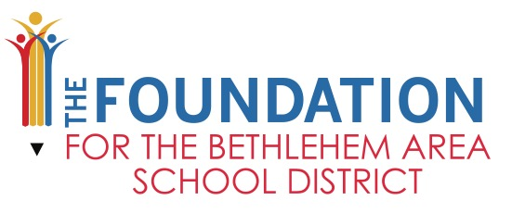
2020/2021 Student Leadership Grants
Application Instructions
Proposal Deadline: Thursday, October 28, 2021

PURPOSE FOR STUDENT LEADERSHIP GRANTS
Student Leadership Grants are available to Bethlehem Area School District students who are active leaders for their school. Grant funding will be awarded to student leaders whose projects or programs support The Foundation’s mission while supporting our organization’s funding areas of focus: Mental Health, DEIB (Diversity, Equity, Inclusion and Belonging), Nutritional Education, and Career Pathways.

FUNDING
Funding requests of any amount up to $1,500 are acceptable.

PROJECT PERIOD
Grant Applications Open – September 1, 2021
Grant Request Due Date – Thursday, October 28, 2021
Grant Recipients Announced – Friday, November 19th – Tuesday, November 23rd

TECHNOLOGY REQUIREMENT
All grant applications requesting technology items must be reviewed and approved by the BASD Information Services Department. To provide the BASD Information Services Department adequate time to review your application, submit a PDF version of your grant application via email to Scott Best sbest@basdschools.org no later than Friday, October 15th.
***For grants which include technology orders, it is currently anticipated that technology will be delivered to schools no later than February 28, 2022. However, manufacturing delays may occur that may cause the delivery to you to be delayed. If delays occur, you will be notified.***

For your reference, the link below is the approved BASD Hardware list including prices. https://docs.google.com/spreadsheets/d/1Lj52_cvskva7OKVkji2VZXZtHmm5K5VkQVyS1uM0eYg/edit?ts=5a81c42a#gid=0

APPLICATION CHECKLIST
The following items should be included your Teacher Innovation Grant applications:
- Proposal Cover Sheet (administrative and IT signatures required)
- Completed Grant Questions (all questions must be answered or your application will be considered incomplete
- Budget (use template)

EVALUATION CRITERIA
Projects will be awarded based on score. To be considered for funding, a project must meet and include the following criteria (100-point maximum):

EVALUATION CRITERIA | RATING SCALE
INNOVATION: The degree of creativity of a new idea and practice to enhance learning in the classroom, promote family & community partnerships, and/or support academic innovation | 0-25 Points
ALIGNMENT WITH THE FOUNDATION’S MISSION: Describe how the project relates to The Foundation’s Mission and how it is aligned with our areas of support. | 0-25 Points
OBJECTIVES & EVUALTION: Describe the objectives of the project and how each objective will be measured. What are the measurable outcomes of the project? | 0-20 Points
PROGRAM DESCRIPTION: Provide a clear and detailed program description. If applicable, provide dates of project activities | 0-15 Points
BUDGET*: Provide a budget and budget narrative that explains the use of funds | 0-15 Points
TOTAL SCORE | 100 Points
NON-ALLOWABLE BUDGET COSTS Food items, t-shirts, bags, etc. that are used as “extras” or rewards are typically not funded.

APPLICATION SUBMISSION
Submit the application package to The Foundation via BASD Inter-district Mail:

Broughal Middle School – The Foundation for the BASD

All applications should be single sided and NOT stapled together. All instructions and criteria must be followed or your application will be considered incomplete.

QUESTIONS OR FEEDBACK NEEDED
Please contact Julie Bailey with any questions at:
jbailey@basdschools.org or 610-861-0500 ext. 60255

ANNOUNCEMENT OF GRANT RECIPIENT
Julie Bailey, Executive Director of The Foundation will announce winning grant recipients in person at each school on Friday, November 19th, Monday, November 22nd and Tuesday, November 23rd.

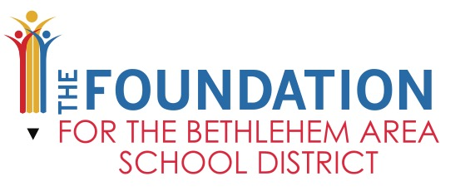

2021/2022 Student Leadership Grant Application
PROPOSAL COVER SHEET

Project Area of Support | Mental Health Career Pathways Diversity, Equity, Inclusion & Belonging  Nutritional Health Other_______________________________________
Project Title
Budget Request Amount $
Name of Student Applicant
Name of Teacher Advisor (Mandatory)
School
Grade Level (s)
How many students will benefit from the project?
Teacher Advisor’s Contact - Phone
Teacher Advisor’s Contact - Email
Teacher Advisor Signature & Date
Applicant

Signature & Date
Principal, Assistant Principal or Department Chair
By Signing, the building Principal supports this project
Signature & Date
BASD IT Department (only needed if Technology is listed on budget)
By Signing, BASD IT Department supports this project

2021/2022 Student Leadership Grant Application
PROPOSAL NARRATIVE (1-3 Pages)

Innovation: Describe the degree of creativity of this program/project and how it relates to enhancing learning opportunities, promoting family & community partnerships, and/or supporting academic innovation.

Alignment with The Foundation’s Mission: Describe how the project relates to The Foundation’s Mission and how it is aligned with at least one of our areas of support (Mental Health, Diversity, Equity, Inclusion & Belonging (DEIB), Career Pathways or Nutritional Health.

Objectives and Evaluation: Describe the objectives of the project and how each objective will be measured. What are the measurable outcomes of the project?

Program Description: Provide a clear and detailed program description. If applicable, provide dates of project activities

Budget Narrative: Provide a budget narrative that explains the use of funding requested. Use the Budget Summary to line list the necessary items for this project/program. Include field trip costs on the Budget Summary using the Transportation Calculation Form.

School
Project Name
Applicant Name

Item | Item Description | Vendor | Item Cost | Quantity | Extended Cost
Example Item | Brief description of example item | Vendor Name | $4.99 | 10 | $49.90
 | Total Funding Requested |  |  |  | $49.90

