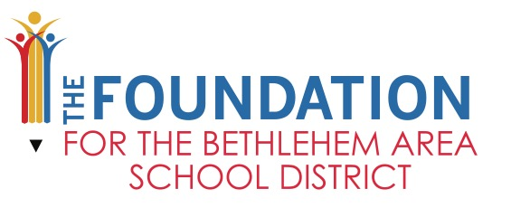

2021/2022 Teacher Innovation and Service-Learning Grant
Proposal Deadline: Thursday, September 30, 2021
APPLICATION INSTRUCTIONS

PURPOSE FOR TEACHER INNOVATION & SERVICE-LEARNING GRANTS

Teacher Innovation Grants are available to Bethlehem Area School District teachers to implement an innovative project, initiative, teaching strategy, technology application or other effort providing measurable educational outcomes for students. The purpose of this grant program is to enhance student learning and student interest in learning by providing educators an opportunity to exercise their passion for teaching, develop their ideas, partner with colleagues and connect with the wealth of knowledge, expertise and talent within BASD and the community. Projects should enhance the regular curriculum, promote family and community partnerships and/or support academic innovation.

Service-learning Grants are available to Bethlehem Area School District teachers to implement high-quality service-learning projects. Service-learning is a teaching strategy that connects classroom curriculum with service projects that engage students socially, civically and academically. A high-quality service-learning experience combines meaningful service with in-depth learning. Service-learning begins with classroom content and moves into the community through the planning and implementation of a service-project.

FUNDING
Funding requests of any amount up to $1,500 are acceptable.

PROJECT PERIOD
Grant Applications Open – August 1, 2021
Grant Applications Submitted to BASD ISD Department (if requesting technology items) – Friday, September 17th
Grant Request Due Date – Thursday, September 30, 2021
Grant Recipients Announced – Friday, October 22nd – Tuesday, October 26th

APPLICATION CHECKLIST
The following items should be included your Teacher Innovation Grant applications:
- Proposal Cover Sheet (administrative signature required and BASD ISD signature, if applicable)
- 1-3 Page Proposal Narrative
- Budget (use template)

APPLICATION SUBMISSION
Submit the application package to The Foundation via BASD Inter-district Mail:

Broughal Middle School – The Foundation for the BASD
Kathy Csatari
Administrative Assistant

All applications should be single sided and NOT stapled together. All instructions and criteria must be followed or your application will be considered incomplete.

TECHNOLOGY REQUIREMENT
All grant applications requesting technology items must be reviewed and approved by the BASD Information Services Department. To provide the BASD Information Services Department adequate time to review your application, submit a PDF version of your grant application via email to Scott Best sbest@basdschools.org no later than Friday, September 17th.
***For grants which include technology orders, it is currently anticipated that technology will be delivered to schools no later than January 31, 2022. However, manufacturing delays may occur that may cause the delivery to you to be delayed. If delays occur, you will be notified.***

For your reference, the link below is the approved BASD Hardware list including prices. https://docs.google.com/spreadsheets/d/1Lj52_cvskva7OKVkji2VZXZtHmm5K5VkQVyS1uM0eYg/edit?ts=5a81c42a#gid=0

EVALUATION CRITERIA
Projects will be awarded based on score. To be considered for funding, a project must meet and include the following criteria (100-point maximum). To view Grant Scoring Rubric, use this link: https://drive.google.com/file/d/1f_BnKtxStyCf91iQw7pXyDB1sVnzFke7/view?usp=sharing

EVALUATION CRITERIA | RATING SCALE
INNOVATION: The degree of creativity of a new idea and practice to enhance learning in the classroom, promote family & community partnerships, and/or support academic innovation | 0-25 Points
OBJECTIVES & EVUALTION: What will students know or be able to do as a result of this project. Describe the objectives of the project and how each objective will be measured. What are the measurable educational outcomes for students | 0-25 Points
CURRICULUM ALIGNMENT: Describe how the project relates to and enhances the regular curriculum | 0-20 Points
PROGRAM DESCRIPTION: Provide a clear and detailed program description. If applicable, provide dates of project activities | 0-15 Points
BUDGET*: Provide a budget and budget narrative that explains the use of funds | 0-15 Points
TOTAL SCORE | 100 Points
NON-ALLOWABLE BUDGET COSTS Below are non-allowable costs and should not be included in grant proposals.
*Food items that are used as “extras” or student rewards such as student breakfasts and/or lunches. Only food that is directly related to the academic outcome of your grant proposal are acceptable (such as school garden).
*Reward items (t-shirts, bags, etc.)

QUESTIONS OR FEEDBACK NEEDED
The Foundation for the Bethlehem Area School District’s Staff would be happy to answer any questions regarding grant applications and provide feedback on your application. Please contact Kathy Csatari with any questions or for grant application feedback at:
kcsatari@basdschools.org or 610-861-0500 ext. 60257

ANNOUNCEMENT OF GRANT RECIPIENT
Julie Bailey, Executive Director and Kathy Csatari, Administrative Assistant of The Foundation will announce winning grant recipients in person at each school on Thursday, 10/22, Friday 10/23, Monday, 10/26 and/or Tuesday, 10/27.

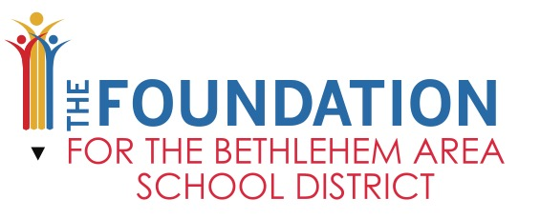

2020/2020 Teacher Innovation and Service-Learning Grant Application
PROPOSAL COVER SHEET

Project Category | Innovation Service-Learning
Project Area of Support | STEM Business Reading/Literacy Arts  Music Mindfulness Equity/Anti-Racism/Social Justice  COVID-19 Response Other_______________________________________
Project Title
Budget Request Amount $
Name of Applicant (only 1 Teacher Name)
School
Grade Level (s)
How many students will participate?
Applicant’s Phone
Applicant’s Email
Signature & Date
Applicant

Signature & Date
Principal, Assistant Principal or Department Chair
By Signing, the building Principal supports this project
Signature & Date
BASD IT Department (only needed if Technology is listed on budget)
By Signing, BASD IT Department supports this project

2020/2021 Teacher Innovation and Service-Learning Grant Application
PROPOSAL NARRATIVE (1-3 Pages)

Program Description: Provide a clear and detailed program description. If applicable, provide dates of project activities

Innovation: Describe how this program/project is an innovative teaching approach which enhances curriculum, promotes family and community partnerships and/or supports academic innovation. Provide the degree of creativity of a new idea and/or practice that will enhance learning in (or outside) the classroom.

Curriculum Alignment: Describe how the project relates to and enhances the regular curriculum.

Objectives and Evaluation: Describe the objectives of the project and how each objective will be measured. What are the measurable educational outcomes for the students and what will the students know or be able to do as a result of this project/program?

Budget: Provide a budget narrative that explains the use of funding requested. Use the Budget Summary to line list the necessary items for this project/program. Include field trip costs on the Budget Summary using the Transportation Calculation Form.

School
Project Name
Applicant Name

Item | Item Description | Vendor | Item Cost | Quantity | Extended Cost
Example Item | Brief description of example item | Vendor Name | $4.99 | 10 | $49.90
 | Total Funding Requested |  |  |  | $49.90
***If applicable, Field Trip expenses should be reflected on the above budget summary.

