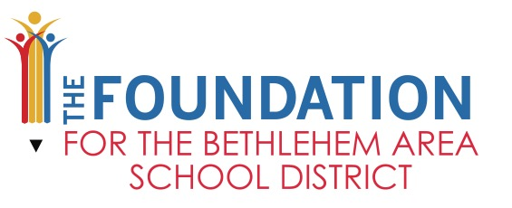
William Burkhardt Scholarship
2022 Application Form
Application Deadline: Friday, April 1, 2022

William Burkhardt Scholarship Fund – provides 1 (one) $500 scholarships for eligible seniors at Liberty High School who plan to include the arts in their college experience. Students must provide all information to be eligible for the award. Completed applications should be submitted to the guidance office not later than Friday, April 1, 2022.

Student Name:_______________________________________________________________________

Home Mailing Address:________________________________________________________________

College or University chosen:___________________________________________________________

Enrollment Start Date:________________________________________________________________

Planned Graduation Date:_____________________________________________________________

Student ID or Bursar Number:__________________________________________________________

Planned course of study (please elaborate on educational plans):

_____________________________________________________________________________________
_____________________________________________________________________________________
_____________________________________________________________________________________
_____________________________________________________________________________________
_____________________________________________________________________________________
School of Attendance: _____________________________ Graduation Date: _________________
Current GPA: ____________________________________ Class Rank: ______________________
I understand that my eligibility for this award is based on all information provided above being accurate and reflective of my educational plans at this time.
Signature:________________________________________ Date: ___________________________

P.O. Box 646, Bethlehem, PA 18016 Email: TheFoundation@basdschools.org 610.861.0500 ext. 60255

